**PB**

* **Fix physics interactions which appear to be broken**
* **Why does yellow/orange block disappear?**
* **Fix the insert points for model and also leap pointer relative adjustment.**
* **Editing object properties – size, position.**
* **Invert textures (y-axis/rotation).**
* **Texture scrolling on objects.**
* **Object palette – getting rotating objects on palette (0.5)**
* **Drag and Drop to model – placement with mouse click (0.5)**
* **Leap integration with model (0.5)**
* **Packaging (1.0)**
* Submit to Leap Motion for feedback (0.5)
* When removing a project file the default position for saving the new one is over the top of the old position – should probably default to a new directory.
* Export model to separate XML
* Import model from separate XML
* Edit model source in BrazilEditView perhaps?
* Scene/State editing
* Scene/State add
* Scene/State delete
* Export to uhro
* Export to XNA game/build mechanism
* Export to Android template
* Leap integration with game (2.0)
* State -> screen representation (meta editing for states)
* Kinect Fusion capture integration
* Website update with production/service launch
* Website/Xyglo logo
* Leap – get normals of fingers, find out the direction of rotation when spinning hand.
* Website redesign.

**Done Sprint #1**

* **Start/Stop restart model (1.0)**
* **Centre model/fix (0.5)**
* **Cursor select for objects (0.5)**
* **Delete objects (0.5)**
* **Fix the highlight (proper highlight)**
* **Object palette (1.0)**
* **Drag and Drop to model (0.5)**
* **Leap integration with model (0.5)**

**9th April**

* Did some website planning. Did some customer planning.
* Fixed the highlighting to use wireframe boxes.
* Fixed a physics world/delete bug.
* Got inserting into model working.
* Planned: Fix the insert points for model and also leap pointer relative adjustment.
* Planned: Invert textures (y-axis/rotation).
* Planned: Texture scrolling on objects.
* Planned: Fix physics interactions which appear to be broken.

**8th April – April (From Weekend)**

* No progress.
* Planned. Define business audience. Individual developers, SME marketing.
* Leap – getting the normals of fingers to decide on rotation direction.

**7th April – Standup (From Weekend)**

* Played with Leap integration – got circle gesture working for wind in/wind out.
* No other progress but thinking about markets and target audience.

**6th April – Standup**

**Done**

* Created basic Object Palette

**Today**

* Today need to get palette working with objects superimposed
* Allow selection of Object
* Work on Leap finger detection – number fingers
* Leap positional rotation of objects
* Placement of objects

**5th April – Standup**

* Did transport, centre model/fix, delete objects, cursor select
* Start thinking about model -> state editing and how projects relate to apps

**4th April – Standup**

* Start/Stop model can change to ‘Reset app’ button/controls as we don’t need fine grained control over app model yet.
* Leap – moved up to new version of SDK. Gestures might be more consistent now. Need to think about integration with modes.

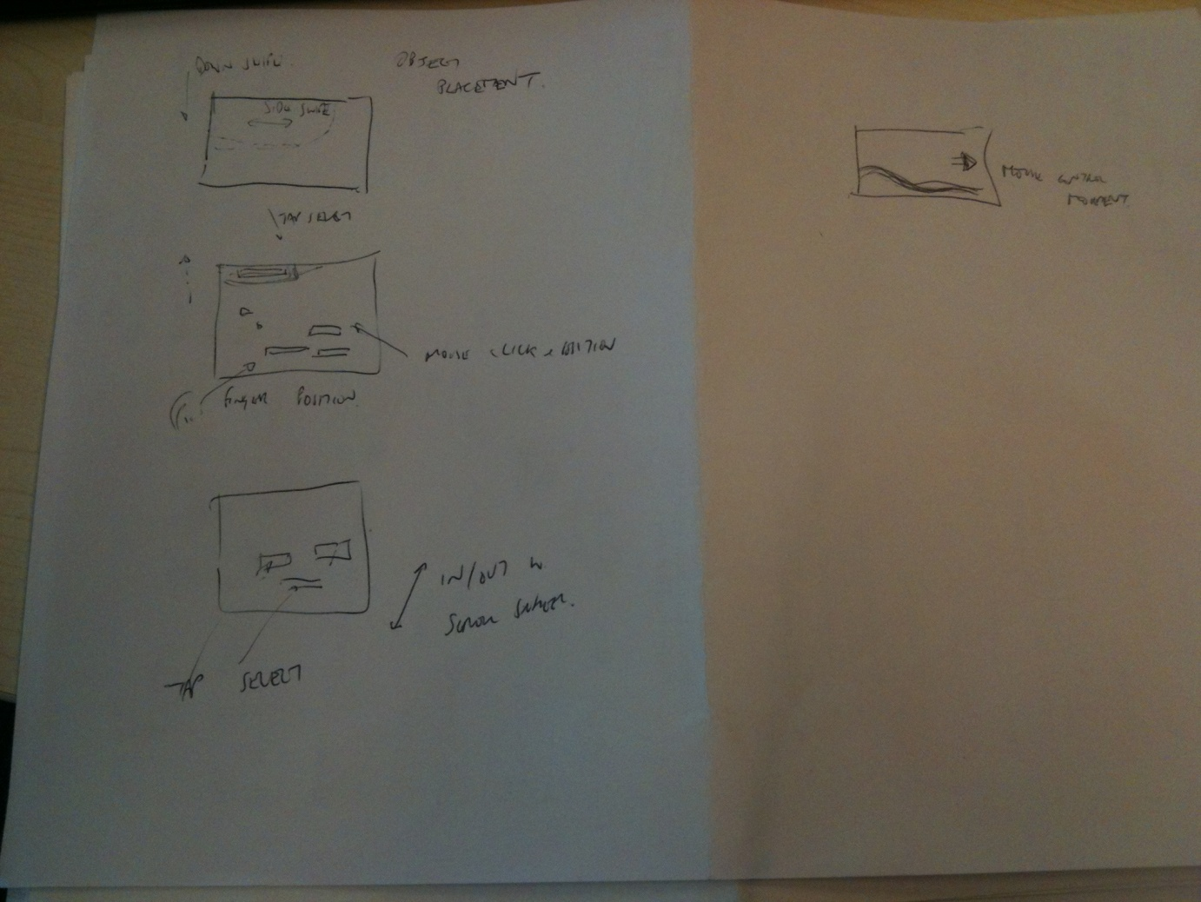

**3rd April 2013 – Objective Setting Sprint #1**

Three opportunities identified for April

1. The Leap Motion launch happens in May – and Leap want to see my software so they can promote it on their website. Some form of Leap integration would be great.
2. Android implementation in Urho3D direct into Android/Windows from Friendlier.
3. Kinect 1.7 SDK with the object capture API.

Notes:

Output stage to urho3d

Input modification means

* Editing objects/properties
* Object palette
* Dragging from palette to model
* Editing model
* Cursor on model
* Saving model
* Export/import model

State editing

* Screen representation
* Add state
* Delete state
* State types -> Menu Screen, Game Screen, High Score, IA Purchase

**2nd April 2013**

**Marketing**

* Branded game app service
* Branded business app service
* Advertising share/Ad free premium service

Game app

Rock Star

Beer nuts

Bowling

Space game

Branding of these.

Opportunities:

* High score board
* Drives loyalty
* In pub/in club

Pricing?

Per app, # of customers, across chain support

Start Small

* Create apps and sell them
* Personalised web page for app results and high scores

Tiers

* Basic app on android w. advertising and share of profits
* Provide graphics
* Design graphics

Basic app and updates:

* Monthly push campaign
* Monhtly email
* Monthly menu updates for example

Demographic

* 8-12 – toy shops
* 12-16 – bands/music/clothes/food
* 16+ - fast food/clothes/music
* 18-24 – bars/pubs/clubs/music

Start small… think big

Organisations

* Toy chains
* Super markets
* Cinema chains
* Bowling alleys
* Drugs companies

App deployment and development

First offer:

1 App = $499 incl share of add revenue

5 apps @ $299 each for same template

10 apps @ $1999 each + 1 year updates

Repeat pacjkge with new images from $89

Sample apps

* 10 pin bowling
* Darts
* Beer drinkin/pouring
* Pop corn throwing
* Food/menus/maps/food game

The Xyglo Restaurant – The Wilted Xygloid

**Tech**

* Build 3D app w Uhro template
* Modify template w. placeholders
* Publish from friendlier